**Assignment 3: Preparing Reports**

**Data Set: Super store**

1. **Prapare a report showing product category wise sale**

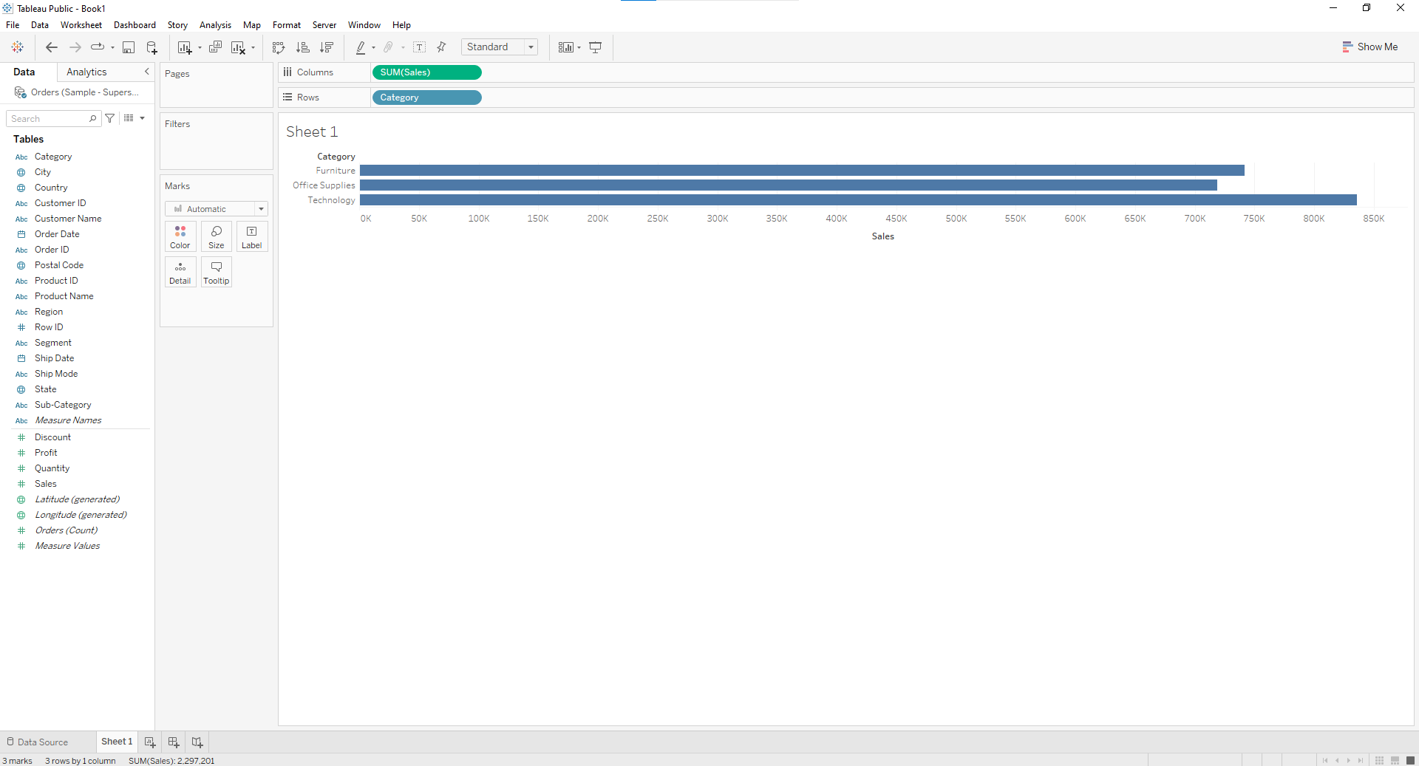

1. **Report showing regionwise productwise sales**

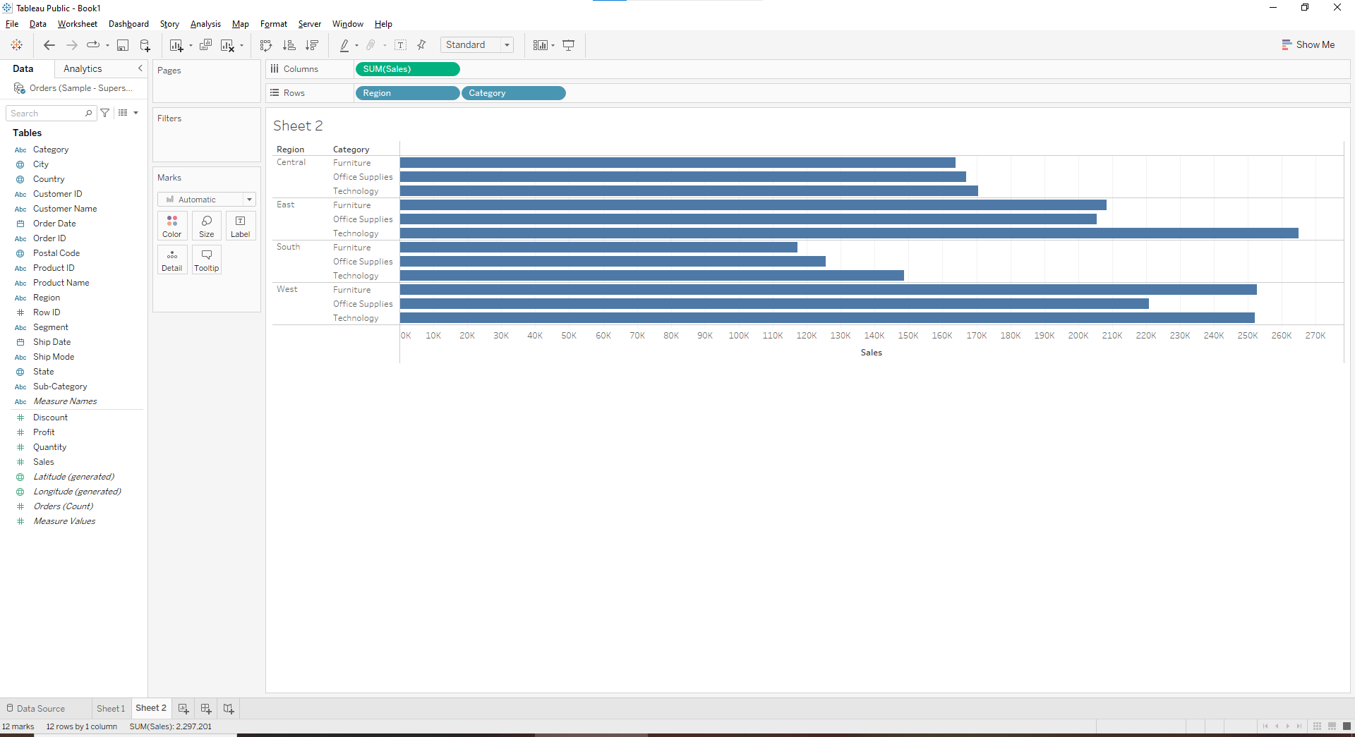

1. **Report showing statewise sales**

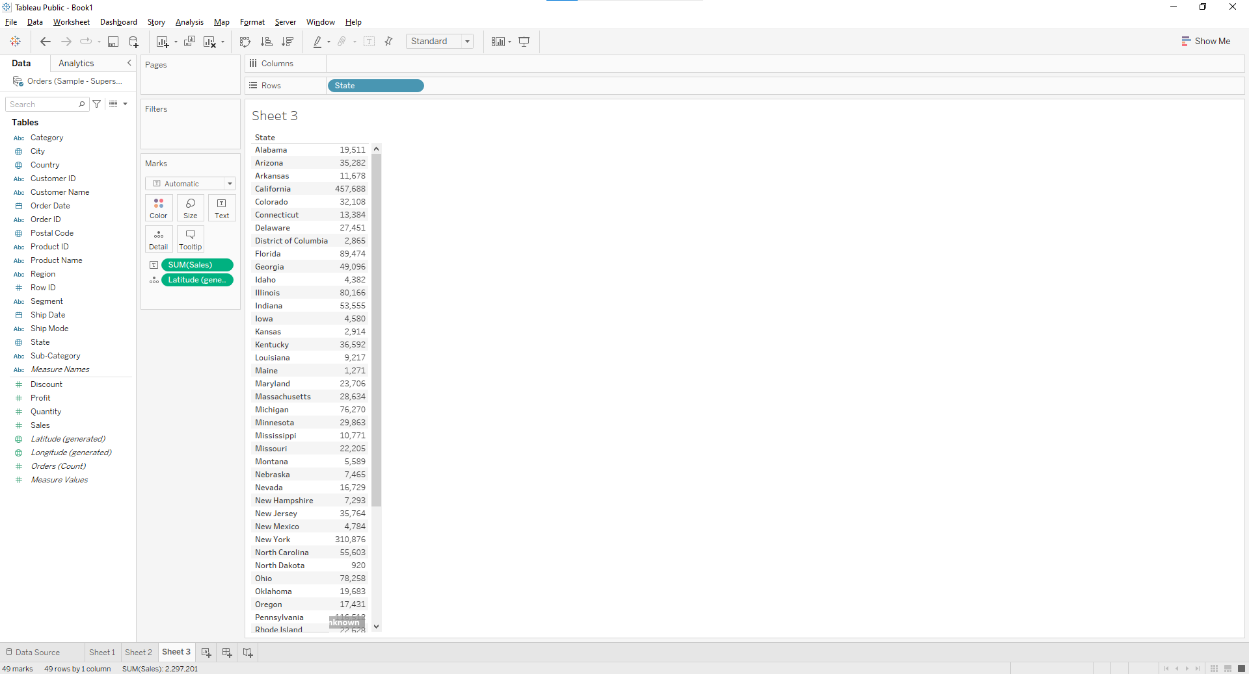

1. **What is the percent of total Sales for the ‘Home Office’ Customer Segment in July of 2014?**

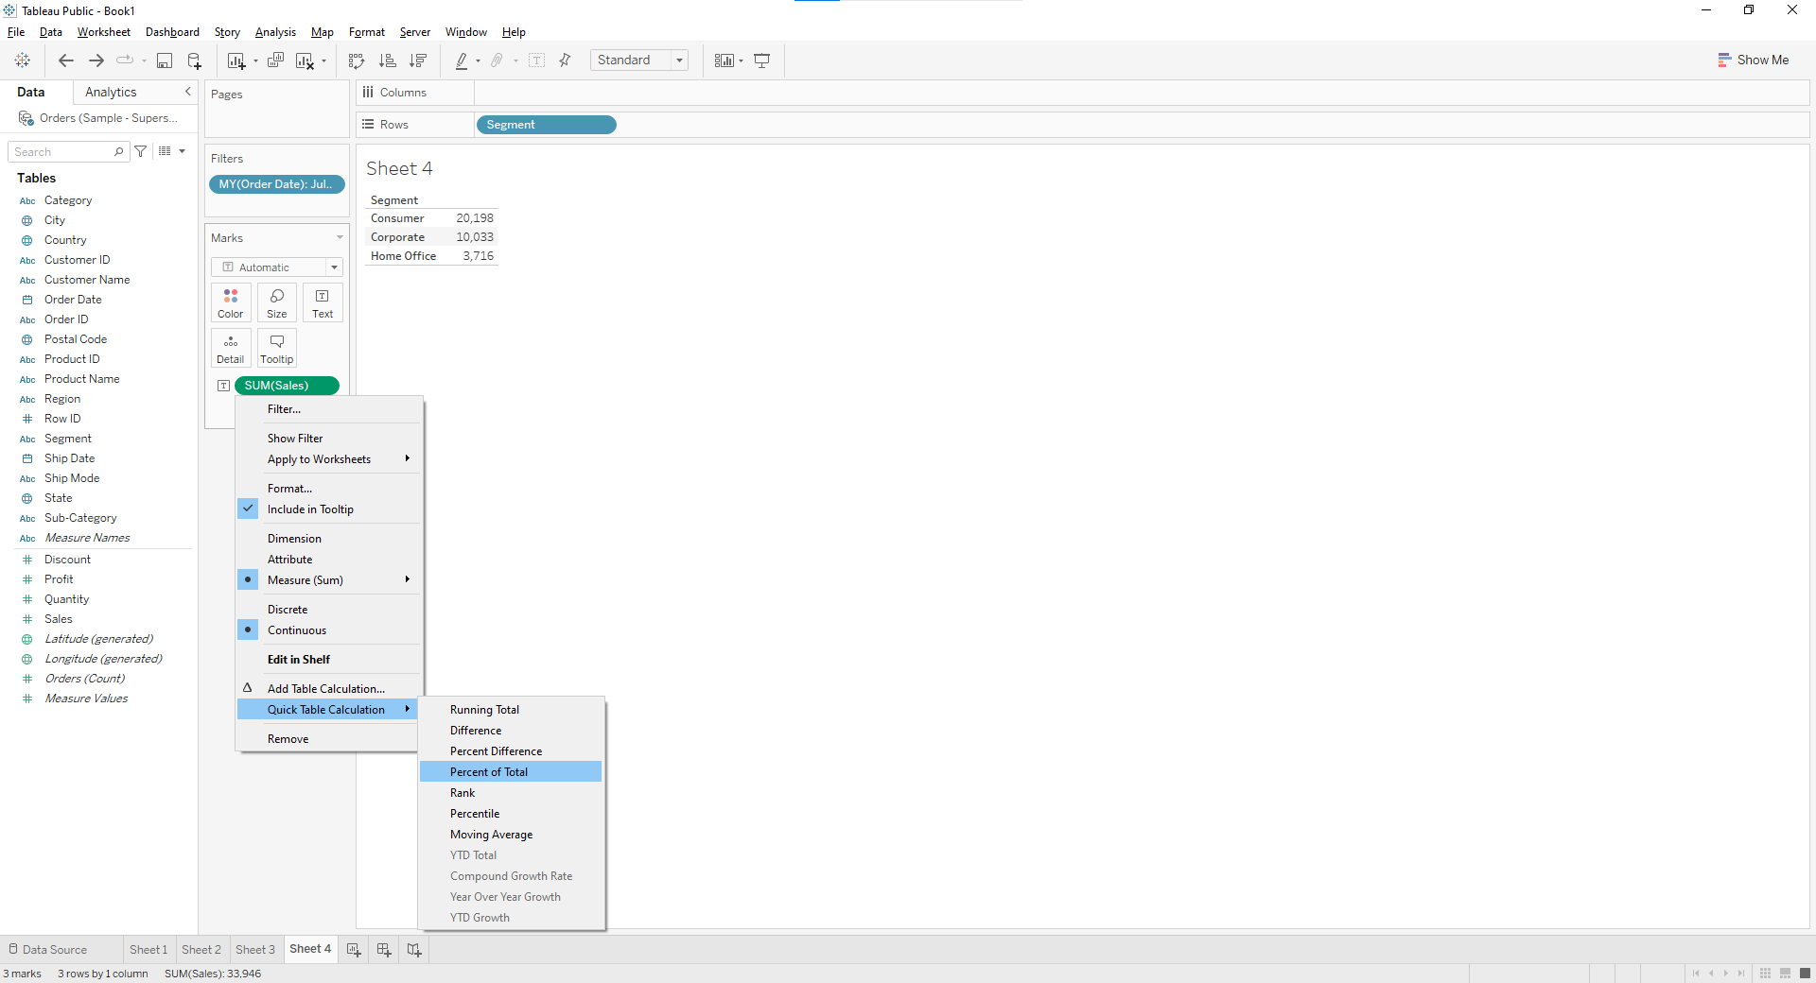

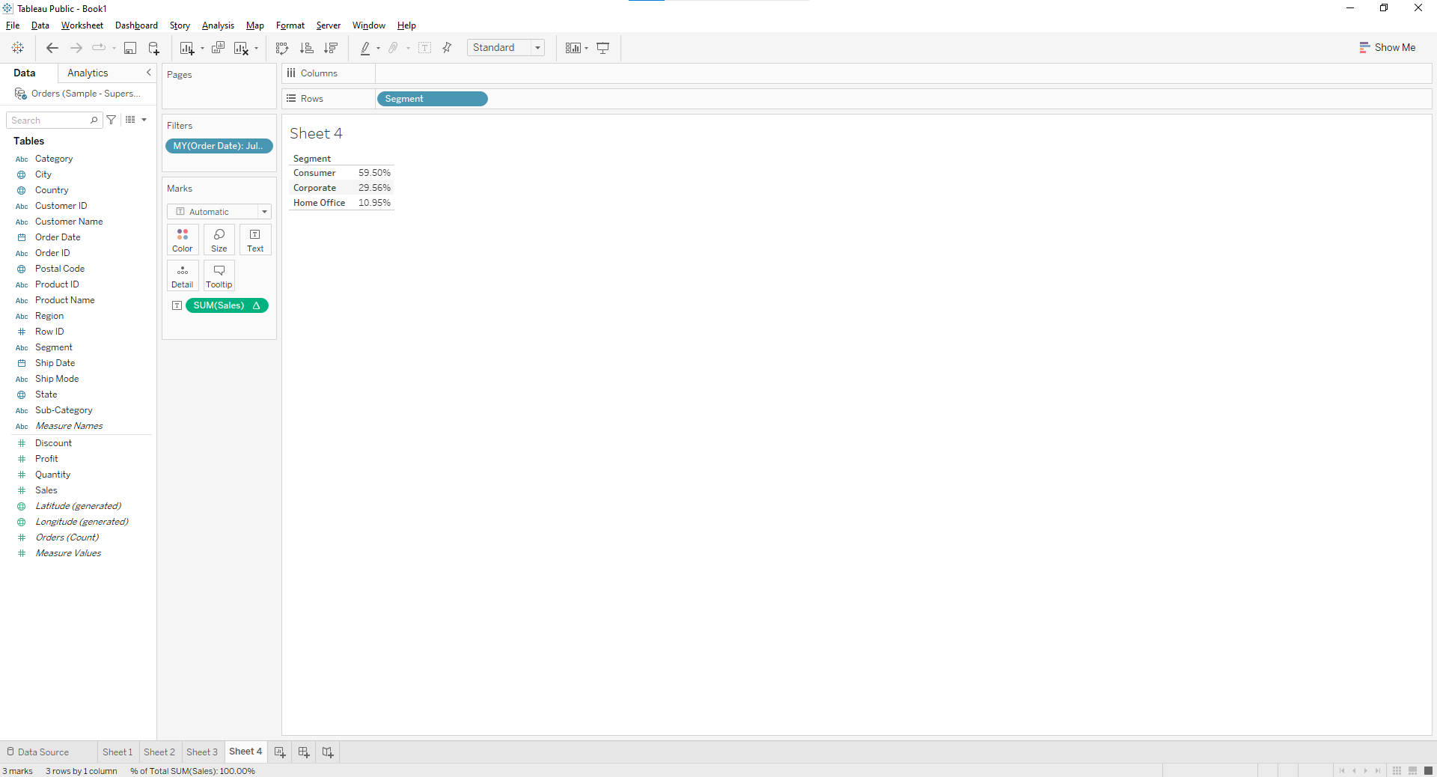

1. **Find the top 10 Product Names by Sales within each region. Which product is ranked #2 in both the Central & West regions in 2015?**

**Drag “Product Name” dimension from data pane window to Row Shelf and then add an “order Date” on Filter shelf and select “Year” of Order date as 2015.After that put region on Filter shelf and select “Central” and “West” checkbox. Also, put a copy of region to the Column shelf as well.**

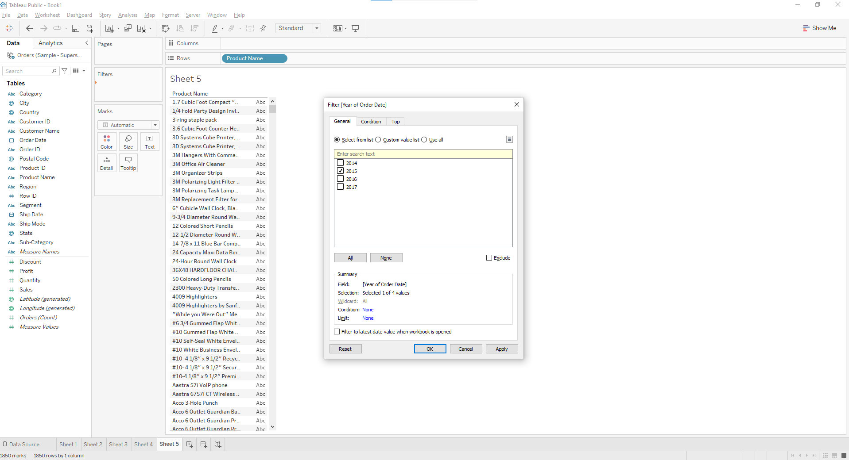

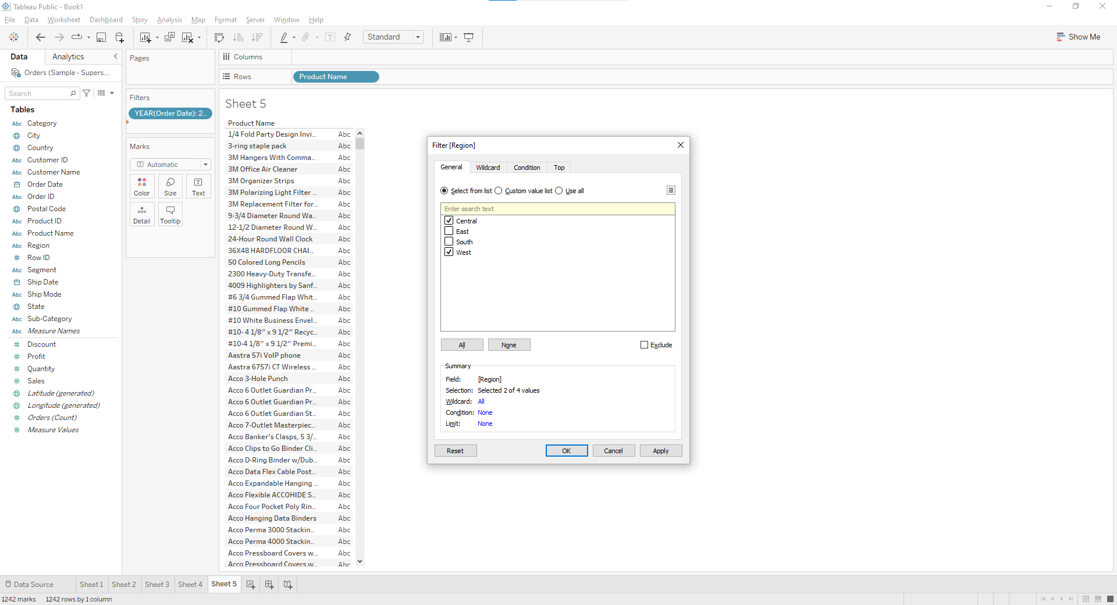

**Drag a Sales measure to the text label. So for getting the Top 10 “product name” by sales, we need to add the “Product name” on Filter shelf. Once the Filter Pop up is open, Select “TOP” tab >By Field > Top 10 by Sum (Sales).**

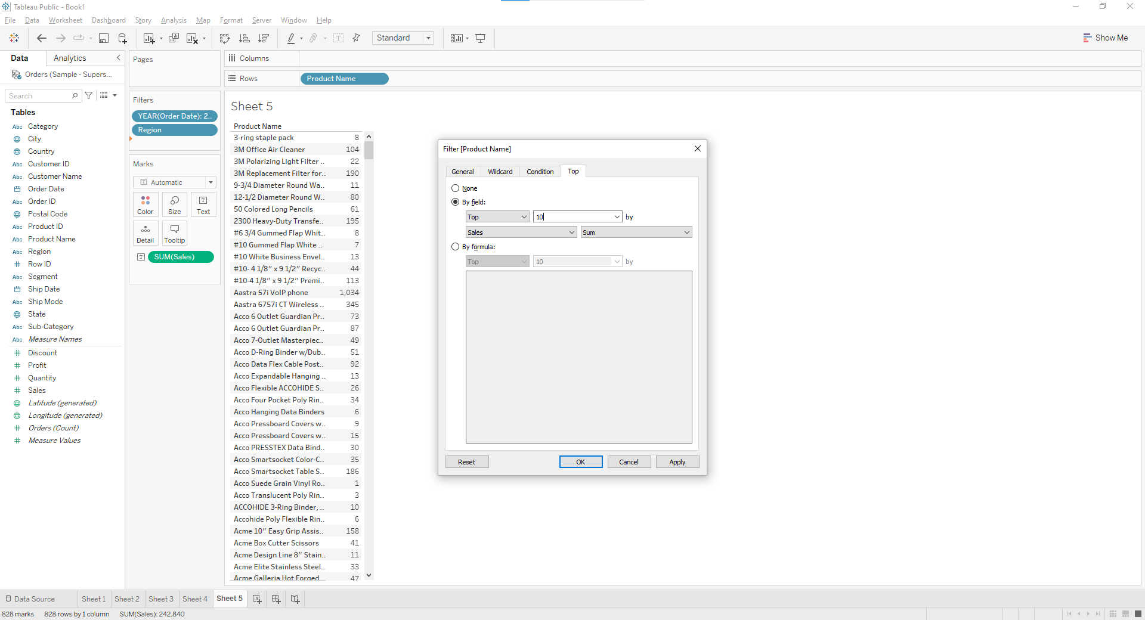

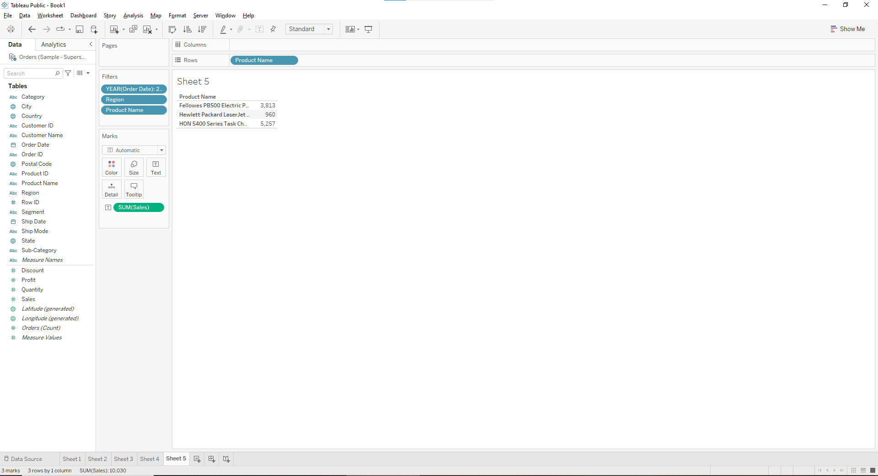

**Right click on the aggregated Sales measure and click on arrow sign then select Quick Table Calculation > Rank. As the default addressing is Table across, please change it into Table Down (Compute using -> Table Down).**

